PCM1808 Module
This mode can have some issues depending on the vendor.
  - Input Filter and Attenuation
Firstly, to make sure a high-output guitar or bass does not cause unintended clipping of the signal, it is recommended to replace the input filter on the board with a 100k resistor:
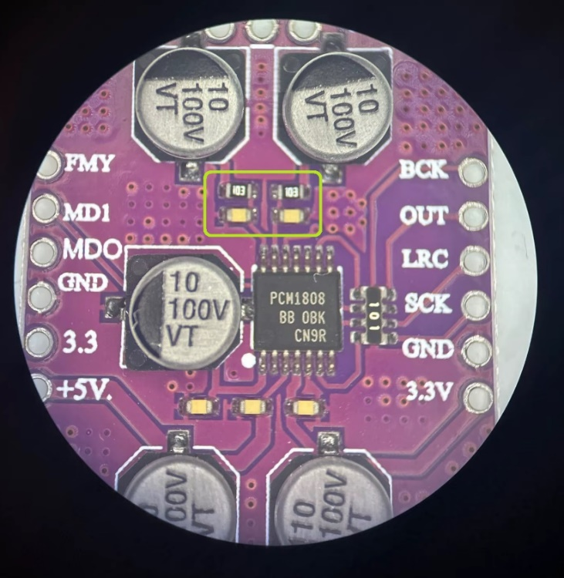
Simply removing the existing 0603 parts allows for soldering an 0805 resistor on the existing pads. If needed, it can placed diagonally making sure to not short the ground pad.
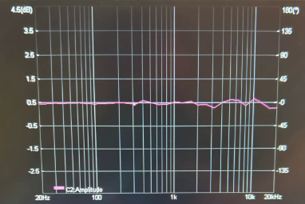
The modules I ordered came with wrong filter values of 10k + 10nF causing a low-pass filter of ~1.6kHz. So, replacement of these parts might be necessary depending on the vendor and manufacturer.
This bode-plot shows the frequency response if you simply short the resistor and remove the capacitor.
100k is safe, but you can play with the value to get the input level and range your application / guitar likes.
Higher values Lower input, reduce clipping
Lower values Higher input, improved SNR
  - Wrong PCB layout!
My second order arrived with a mistake in the PCB layout! (left image is the a good layout)
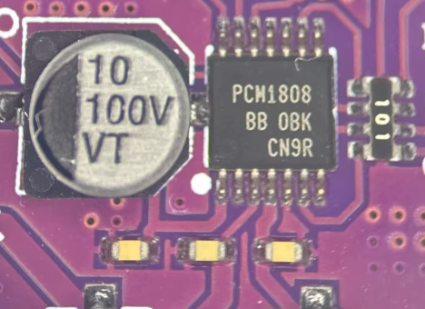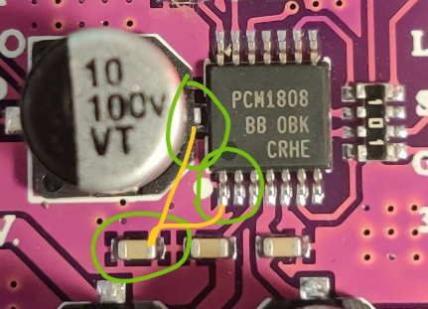
The right image is from another customer that tries to depict the intended traces.
This layout error cuases the bias voltage pin of the ADC to be shorted to ground!
The board will not work like this..
One way to salvage it is to cut the traces / ground plane arount the pin and solder a THT 10uF capacitor to GND. Make sure to also add a ceramic 100nF cap (just to follow the datasheet recommended values).
Optionally, the pin can be lifted instead.
Capacitor rating of > 15V should be more than enough.
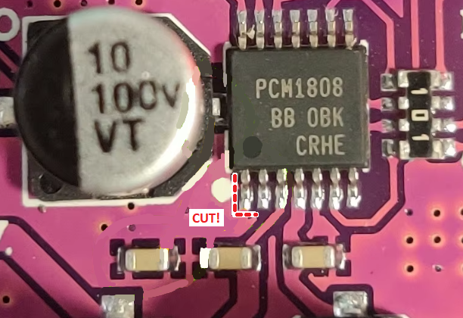
Just make sure to disconnect it from ground and add the two capacitors!

